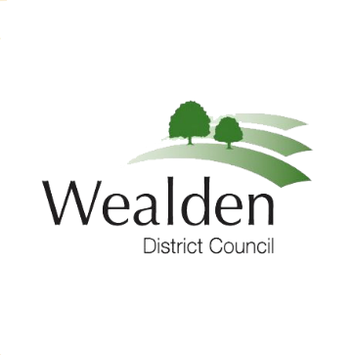

MEDIA RELEASE

014/ 20 27 March 2020

Volunteers to help support our communities

As part of the national effort to support vulnerable people in self-isolation, Wealden District Council is asking for volunteers to help as we all work to limit the spread of the Covid-19 virus.
“We are working with the volunteer organisation 3VA to identify residents who are able to help reach out to self-isolating households either by delivering foodstuffs and medicines or just providing vital social contact through a chat over the telephone,” Councillor Philip Lunn, Wealden Cabinet member for Community & Public Health. “We know many people self-isolating are already being well catered for. The villages and towns across Wealden have already begun making additional supporting arrangements. But we need to make sure no-one is forgotten. That is why the Community Shield scheme is so important.
“I am asking three things:
- If you are able to volunteer to support vulnerable people in self-isolation, please complete the Volunteering Form on the Community Support page of Covid-19 section on the Wealden website.
- If you are in the Government’s category for clinically extremely vulnerable people, and you do not have a support network of friends or family, you can register on https://www.gov.uk/coronavirus-extremely-vulnerable or phone 0800 0288327 for support from the Government. You may have already received a letter about this from the Government.
- If you feel you are vulnerable – or know of someone who is - and need help which friends, family or carers cannot provide, please visit our Covid -19 Community Support page. Complete our online form or telephone Wealden District Council on 01323 443322 and we will put you in contact with groups in the community and voluntary sector who can help.

“Your town or parish council may also be able to help. But if you have an immediate health concern, you should call 111 or 999 in an emergency.
“The Covid -19 information pages on our Wealden website are being updated daily with information and advice about health, council services, help for local businesses and information about Community Support. We are also sharing information through Facebook and Twitter.
“I urge everyone to follow the Government’s advice to Stay at home, Protect our NHS, Save Lives. I know there is a tremendous feeling of community in Wealden’s towns and villages. Together we are stronger than this virus and together we can beat it.”
All details about the Community Shield initiative, including volunteering, registering as extremely clinically vulnerable and seeking assistance during self-isolation can be found on the Covid -19 Community Support section of our website. Or call 01323 443322.

For further information:
Cllr Philip Lunn,  Cabinet member for Community and Public Health.  Wealden District Council.  Tel: 01892 601105  Email: cllr.philip.lunn@wealden.gov.uk | Or | Jim van den Bos  Communications Officer,  Wealden District Council.  Tel: 07985 812076  Email: jim.vandenbos@wealden.gov.uk

